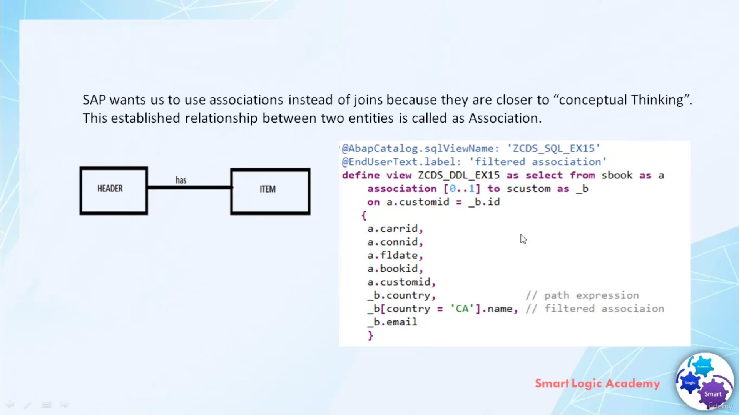

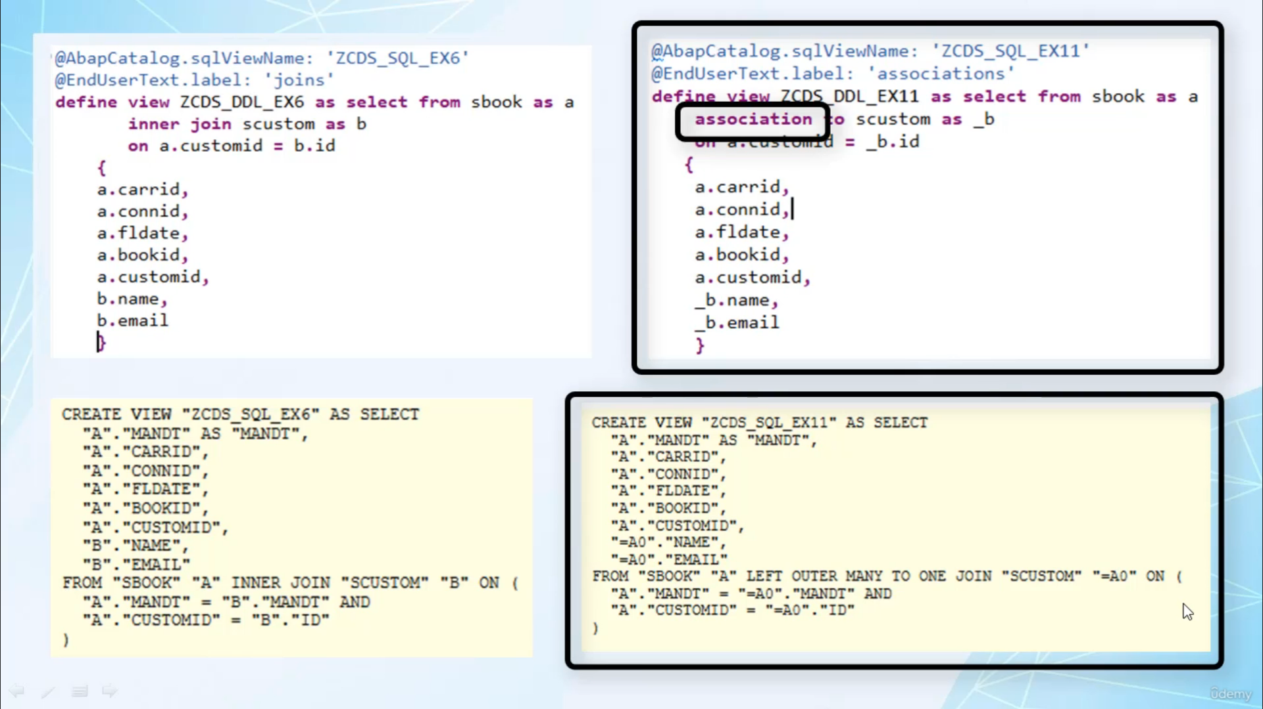

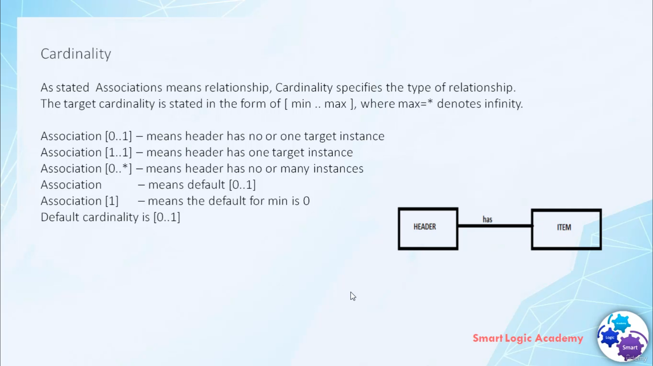

In this video, I will tell you about the associations and how we can use associations in Ababinili

view.

So let's start.

Relationships are often reflected as foreign key relationship in the database, but in a school, the

relationships are often hidden behind the joint conditions.

Hence, our Web series will provide extended support for trading relationship between entities in the

form of associations associations helps to establish a relationship between two entities.

Simply want to use associations instead of joints because they're closer to conceptual thinking and

has some advantages over normally joint.

Associations are easier to read and add some additional features, such as associations may contain

additional semantic information in general cardinality about experiencing associations with the underlying

data, model and origin of data.

Winter conditions are easier to read than weather conditions or case experience, so these are some

advantages of using association or what joins.

Although associations and joints look different, there is no difference on database level, eventually

any association is translated into an ordinary joint.

But in case of so-called expert associations, which depend on the weight of view consume the joint

is only executed if the customer request data from the associated datasource.

This can have a positive effect on performance and sometimes is referred to as a joint on demand and

hence a situation improves the performance.

The school, a statement for vilification, reveals that on the level associations is nothing more than

a joint definition.

When you define an association you can use a religion is to specify an alias associations.

And that looks very similar to the definition of alias in the joint index.

A meaningful name of association further improves the readability of the definition, hence it is recommended,

but not a fixed rule, that the names of association begin with character underscore.

As you know, associations are used to establish a relationship there, cardinality specifies the type

of relationship.

The target cardinality is stated in the form of a square bracket, me, dot, dot, max in this form.

SpacePlane, cardinality of Turkey word association is optional if the cardinality is not explicitly

defined in the cardinality, zero dollars one is implicitly used.

Association with cardinality dot one means Hadit has no one targeting stance, that means based on joint

condition one, the code of Heda has no or maximum one record in item paper.